Tutorial for VisualFigaro Version 2.0
March 2019

By following the steps described in this document, illustrated with a series of screenshots, you will discover all the important functions of the VisualFigaro HMI, needed to create or modify a knowledge base (KB) for KB3.

CONTENTS

1 Creating a new knowledge base 2
2 Writing the Figaro language part of the KB 4
3 Creating a graphical interface for the KB 8
4 Editing an existing knowledge base 9
4.1 Editing General Data 10
4.2 Editing processing models 10
4.3 Editing the list of nodes and links 11
4.4 Editing a particular link 12
4.5 Editing a particular node 15
5 Translating an existing knowledge base 17
6 Editing system models 20
6.1 Creating a new model 20
6.2 Inserting a new object 21
7 Checking the consistency of the model 23
8 Generating a Figaro 0 file 24
9 Lauching Fig0debug 25
10 Launching Figseq 27
11 Launching Yams 28
12 Generating a fault tree 29

Creating a new knowledge base

Once you have launched VisualFigaro, you need to select the menu shown below to create a new knowledge base.

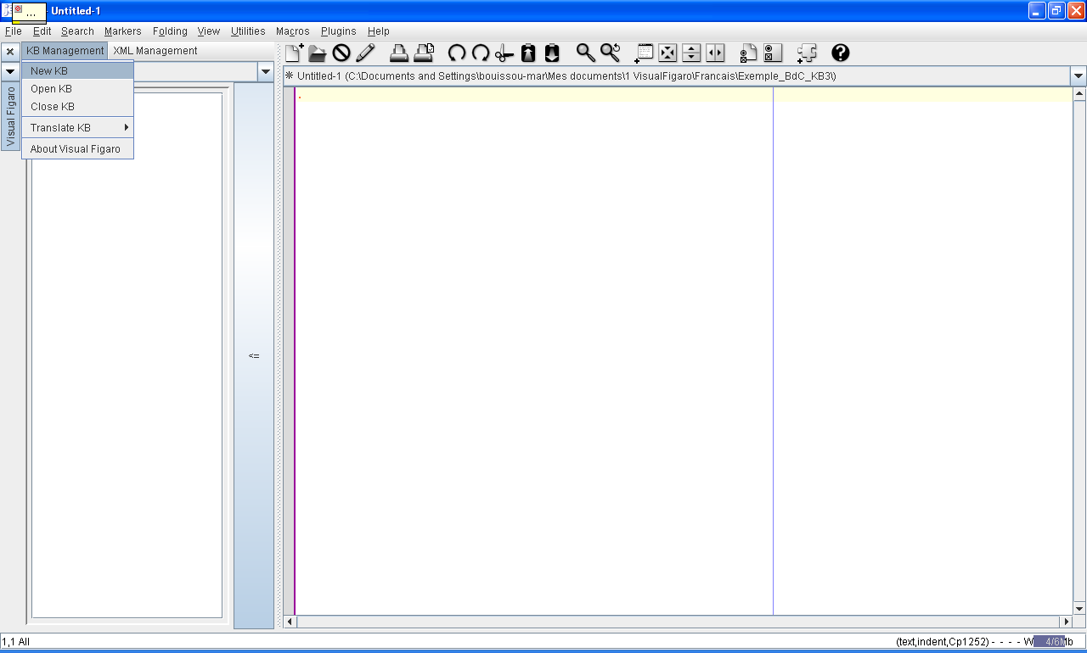

You then obtain a small window such as this:
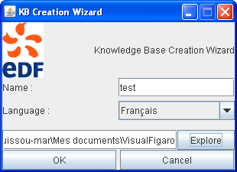
This window allows you to choose a name for the knowledge base (which will become the name of a directory D containing all the files related to the KB) and a directory in which D will be placed (using the "Explore" button).

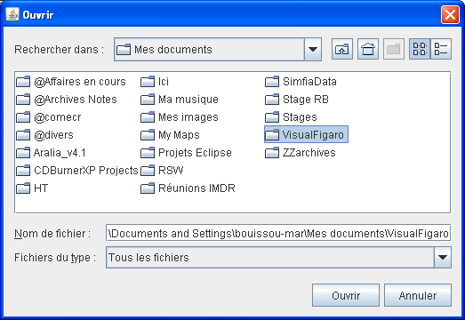

VisualFigaro then creates the D directory in the location specified through the window above (select a directory and click "Open") and creates the following set of files:
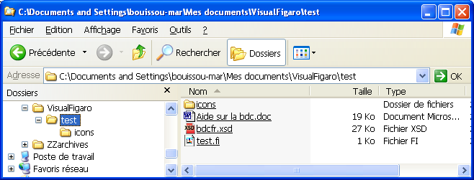

Next, VisualFigaro opens the knowledge base that was just created, initializing the Figaro text by the simple declaration of a class "component":
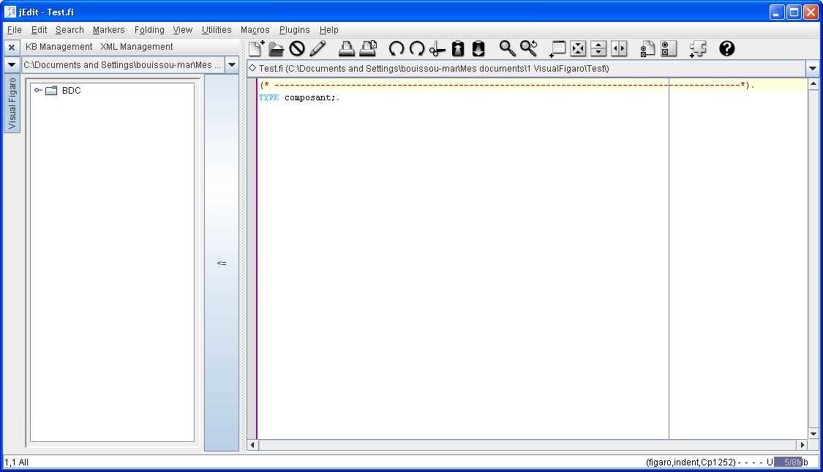

This initialization is configurable in the file called "CopiedFiles.xml" which is part of the set of files installed with VisualFigaro, whose organization is visible in a screenshot of Windows Explorer below.
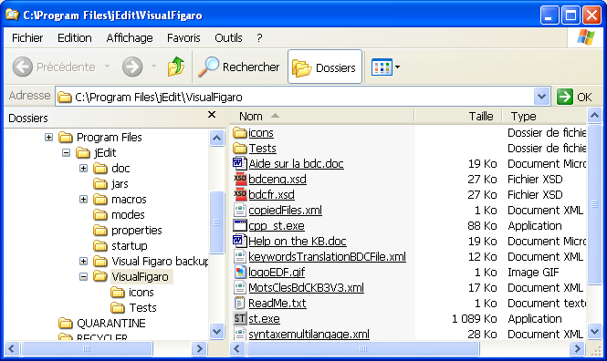

Writing the Figaro language part of the KB
You can then use the "templates function" to write expressions in Figaro language, by right-clicking on the root element called BDC of the tree displayed on the left:
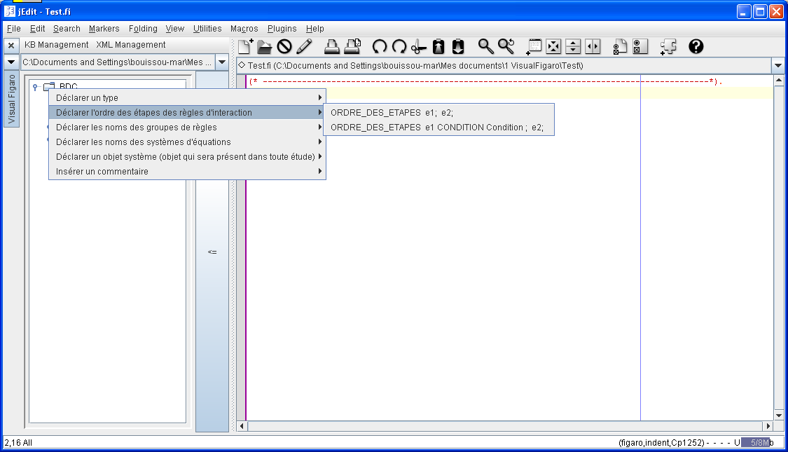

By selecting an item from the second menu level, you place the corresponding piece of text written in Figaro syntax in the clipboard. Then simply paste this text to the desired place in the text editor located in the right pane and then modify it, as in the example below:
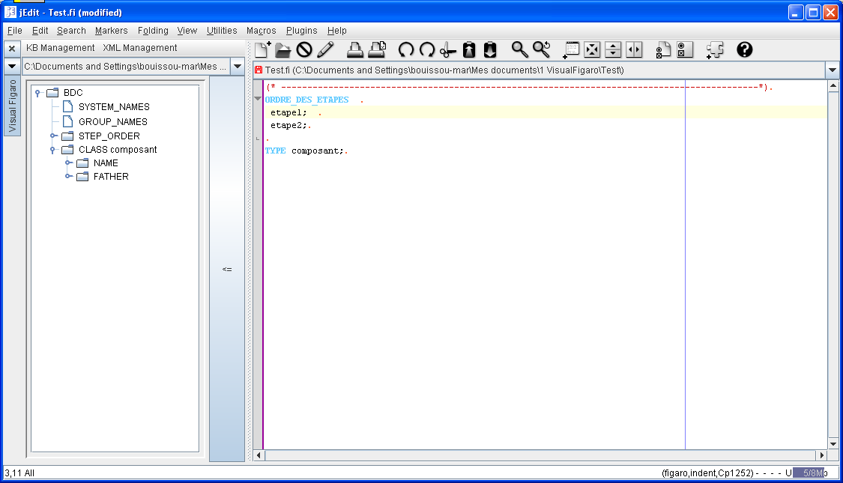

By right-clicking on a class in the window on the left, you get the list of rubrics that can be declared in a class:
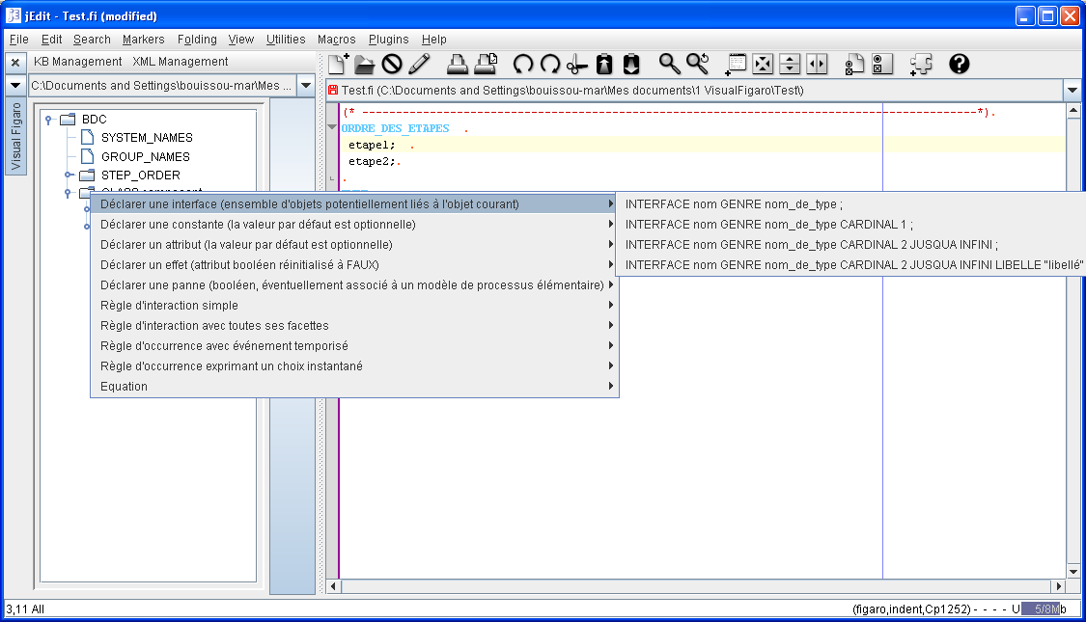

The file containing these various syntax aids is an XML file called "syntaxemultilangage.xml", visible in the tree presented above. This file contains the syntactic aids for the French and English syntaxes of the Figaro language.

NB: For an overview of the concepts and syntax of the FIGARO language, refer to the "FIGARO language reference manual" (designed for linear reading) and to the "FIGARO Syntax manual".

While editing the Figaro text, you can at any time click on the large vertical button that separates the Figaro part from a syntactic tree, which has the effect of saving the Figaro text (NB: in case of inappropriate modification, you can go back using the cancel function of Jedit), checking the syntax of this text and refreshing the tree.

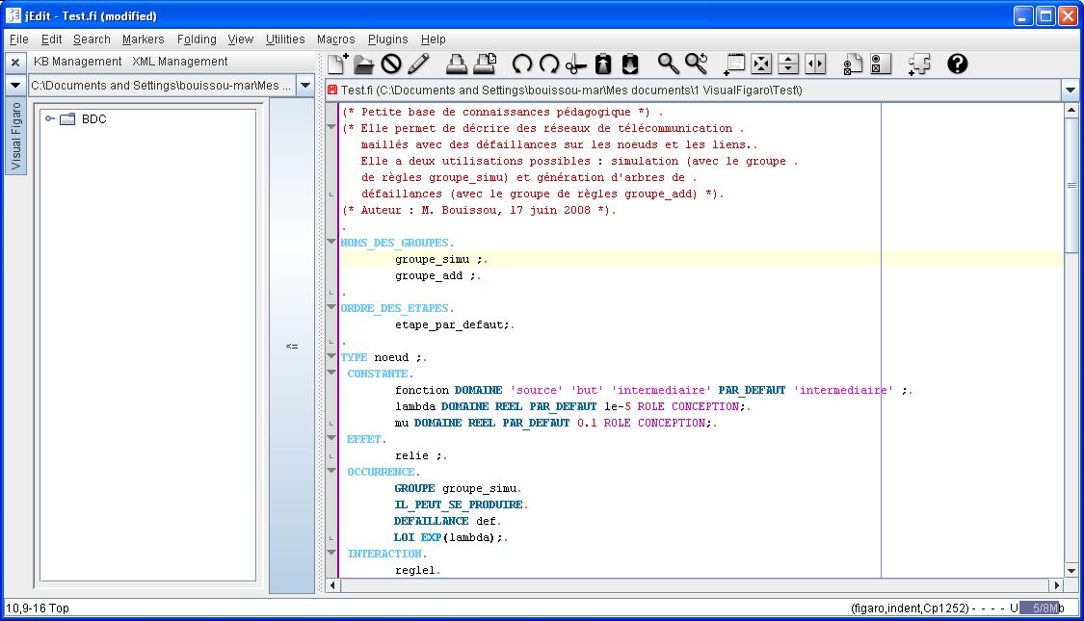

Then, you can easily navigate in the Figaro text thanks to the correspondence between the position of the cursor in the tree and in the Figaro text.
In order to facilitate the step described in the following paragraph, it is important to indicate, by adding the keywords GR_NODE or GR_LINK which classes (and sub-classes, by inheritance) are intended to be represented graphically by nodes ( respectively: links).

Examples of such declarations:
CLASS target GR_NODE KIND_OF component;
CLASS link GR_LINK;

There are generally few key words GR_NODE or GR_LINK to add, because all the sub-classes of a class for which one made such a declaration inherit the declared property.

Below is an example of a knowledge base content in Figaro language that can be copied and pasted into Jedit to continue this tutorial with rich enough content.

(* Small pedagogical knowledge base *)
(* It allows to describe meshed telecommunication networks
with failures on the nodes and the links.
It has two possible uses: simulation (with the group
of rules simu_group) and generation of fault trees
(with group of rules FT_group) *)
(* Author: M. Bouissou, 20 dec 2007 *)
GROUP_NAMES
simu_group ;
FT_group ;

CLASS node GR_NODE ;
CONSTANT
function DOMAIN 'source' 'target' 'intermediate' DEFAULT 'intermediate' ;
lambda DOMAIN REAL DEFAULT 1e-5 ROLE DESIGN;
mu DOMAIN REAL DEFAULT 0.1 ROLE DESIGN;
FAILURE fail LABEL "Failure of %OBJECT"
RELIABILITY_DATA
GROUP FT_group
MODEL_GLM
GAMMA 0.
LAMBDA lambda
MU mu ;
EFFECT connected LABEL "%OBJECT is linked to a source" ;
OCCURRENCE
GROUP simu_group
MAY_OCCUR
FAULT fail
DIST EXP(lambda);

GROUP simu_group
MAY_OCCUR
REPAIR rep REPAIRS fail
DIST EXP(mu);
INTERACTION
rule1
IF WORKING AND function = 'source'
THEN connected;

CLASS source KIND_OF node ;
CONSTANT
function DEFAULT 'source';

CLASS target KIND_OF node ;
CONSTANT
function DEFAULT 'target';

CLASS link GR_LINK;
CONSTANT
link_lambda DOMAIN REAL DEFAULT 1e-5 ROLE DESIGN ;
link_mu DOMAIN REAL DEFAULT 1 ROLE DESIGN ;
FAILURE
interruption LABEL "The link %OBJECT is broken"
RELIABILITY_DATA
GROUP FT_group
MODEL_GLM
GAMMA 0.
LAMBDA link_lambda
MU link_mu ;
OCCURRENCE
GROUP simu_group
MAY_OCCUR
FAULT interruption
DIST EXP(link_lambda);

GROUP simu_group
MAY_OCCUR
REPAIR rep REPAIRS interruption
DIST EXP(link_lambda);

CLASS mono_dir_link KIND_OF link ;
INTERFACE
start KIND node CARDINAL 1 EDITION NOT MODIFIABLE;
end KIND node CARDINAL 1 EDITION NOT MODIFIABLE;
INTERACTION
rule1
IF WORKING AND connected(start) AND WORKING(end)
THEN connected(end) ;

CLASS bi_dir_link KIND_OF link ;
INTERFACE
extremity KIND node CARDINAL 2 EDITION NOT MODIFIABLE;
INTERACTION
rule1
IF WORKING AND
(FOR_ANY x AN extremity WE_HAVE WORKING(x)) AND
IT_EXISTS x AN extremity SUCH_THAT connected OF x
THEN FOR_ALL z AN extremity DO connected(z);

CLASS fail_counter ;
(* Count of failures in the system (nodes and links) *)
ATTRIBUTE
nb_failures DOMAIN INTEGER DEFAULT 0;
INTERACTION
rule1
GROUP simu_group
THEN nb_failures <-- SUM FOR_ALL x A OBJECT OF_CLASS node OF_TERMS (1 * fail(x)) +
SUM FOR_ALL y A OBJECT OF_CLASS link OF_TERMS (1 * interruption(y)) ;

(* A SYSTEM_OBJECT is a global object that can access the variables of all objects
forming part of the system *)
SYSTEM_OBJECT Failure_counter IS_A fail_counter ;

Once loaded in VisualFigaro, this knowledge base should look like this:
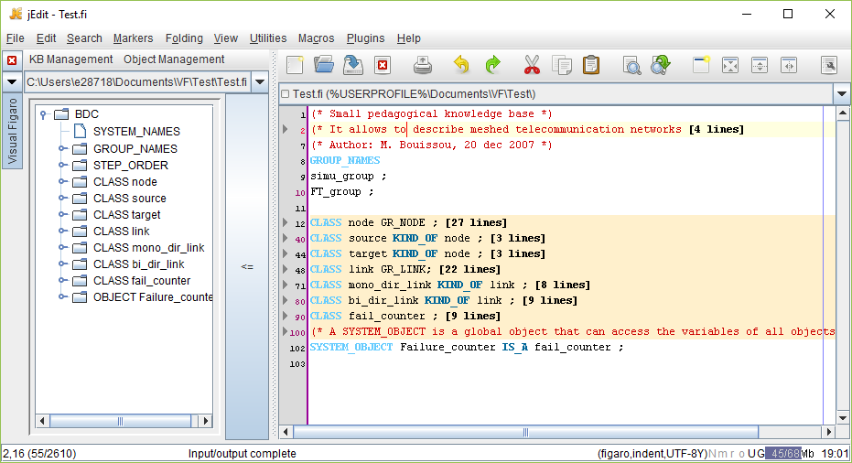

Creating a graphical interface for the KB
You should not take this step before you have a list of almost definitive Figaro classes. On the other hand, it matters little that the content of these classes is not finalized.
Launch the "Edit XML File" command as below:
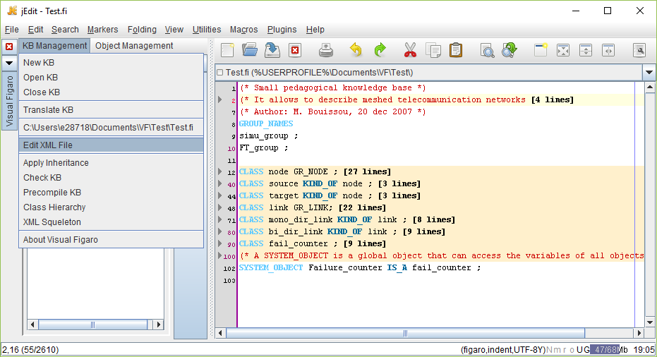

Since there is not yet a file to parameterize the HMI KB3 (file with .bdc extension) VisualFigaro displays the following window:
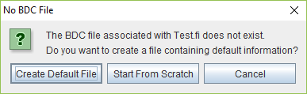

There are two options.
The first is to create a first file containing default information for the set of Figaro classes for which one added key word GR_NODE to declare that it must be considered as a node or key word GR_LINK to declare that it must be considered as a link (Reminder: any class inheriting from a node is a node and any class inheriting from a link is a link).
The second option allows the user to create a file ex nihilo, by using the windows and buttons of the VisualFigaro HMI, but in general, it is better to take the first option: it is much faster because it initializes most dialogs with default data.

Whatever the option chosen, a window appears that contains fields for the input of global information concerning the KB.
We can then save the .bdc file by selecting Save in the menu:
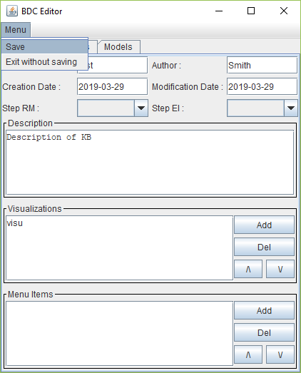

It is now possible to load the knowledge base in KB3, but for a real use, it is necessary at least to complete the instructions for filling the interfaces according to the recommendations of the document. "Knowledge Base Development Manual for KB3 v3 Software".

In the above, all of the specific operations for creating a knowledge base have been detailed. This is why the use of the editing HMI of the .bdc file is detailed in the next chapter, devoted to editing an existing knowledge base.

Editing an existing knowledge base
You must first open the knowledge base from the "KB management" menu. Select a Figaro file, with extension .fi:
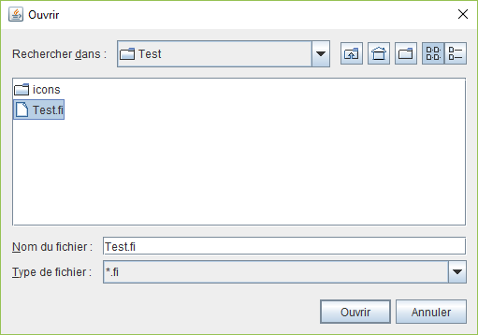

VisualFigaro checks then that the chosen directory contains:
- One and only one schema (bdcfr.xsd or bdceng.xsd),
- No other file with extension .fi than the one chosen,
- A directory called "icons" (in lower case).
VisualFigaro also verifies that the language (French or English) is the same for the keywords of the three files .xsd, .fi, .bdc. If any of these conditions is not verified, VisualFigaro indicates this in an error message and refuses to load the knowledge base.
Once the knowledge base is loaded, you can edit the part in Figaro language according to the principles indicated in the chapter "create a knowledge base". The remainder of this chapter is devoted to the description of the windows that make it possible to edit the .bdc file, which is used to parameterize the HMI of KB3.

Editing General Data
This is done in the main window of the editing HMI of the .bdc file:
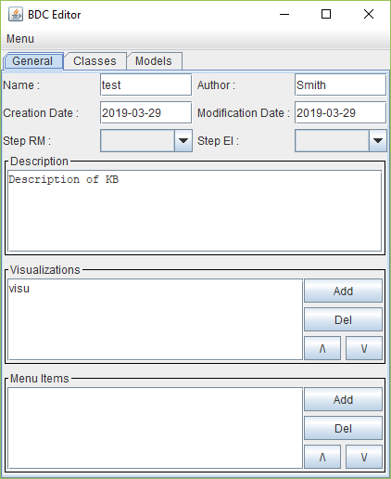
The Description field allows to input some comments about the contents of the KB. Visualizations is the list of visualization modes the graphic variants will have to be related to, and Menu items is the list of names of sub-sets of classes that can be displayed in the palette of KB3, instead of the full list of classes.

Editing processing models
There are three types of predefined Models for which the HMI guides the selection of possible options. We can create as many models as we want in each category.
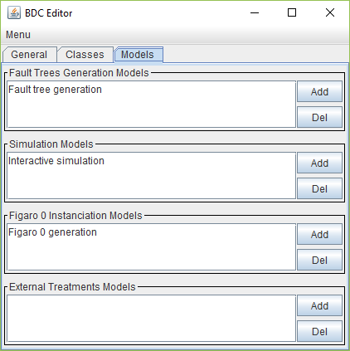
All of these models will appear in the "Processing" tab menus for the KB user under KB3.

Editing the list of nodes and links
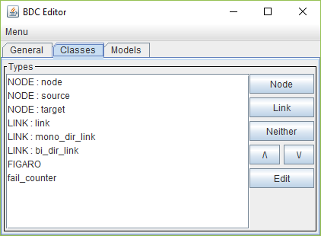
This window displays the list of all classes declared in Figaro language, in the order in which they will be displayed in the graphic palette of KB3. These classes can be viewed from a graphical point of view as nodes, links or neither.

Warning: because of inheritance rules, when a type is declared as belonging to one of the categories (node ​​or link) all its descendants must be declared in the same category. This is why it is useful to be able to say that some classes of high level in the hierarchy do not belong to any of these two categories. The HMI removes any data associated with a class when you select it and click the "Neither" button.
Below is the structure of a class (node or link). Depending on its nature, the structure will contain a substructure NODE or LINK. (NB: this screenshot comes from the free, portable "XSD Diagram" tool).
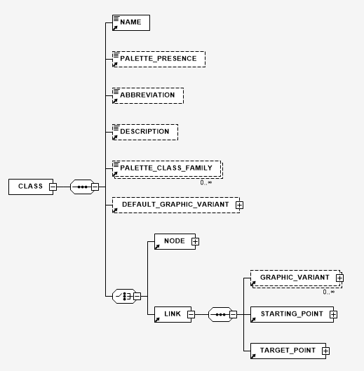

Editing a particular link

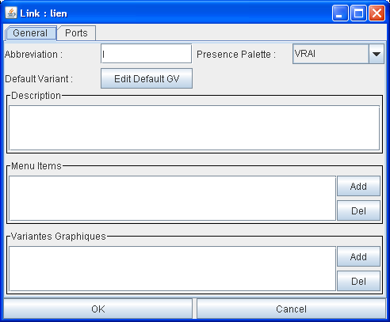

From the General tab (displayed above), one can access the characteristics of the graphic variant by default:
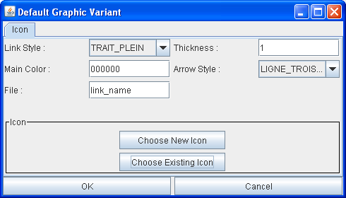

Here is the structure "LINK" of the schema (it is a substructure of "CLASS"):
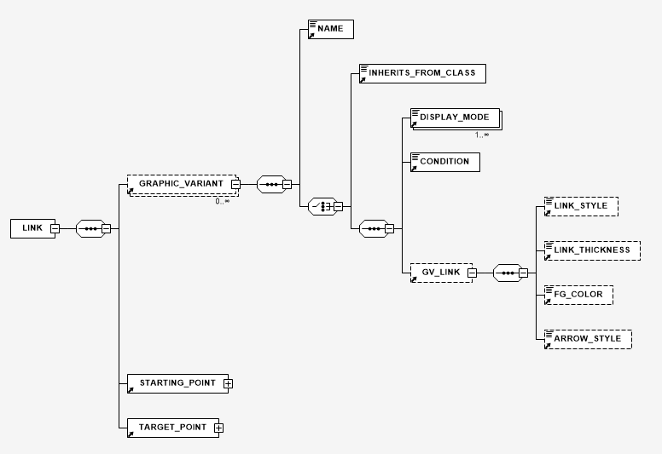

Here is the window allowing to declare graphic variants to be displayed when a condition (to be expressed in FIGARO language) is true.

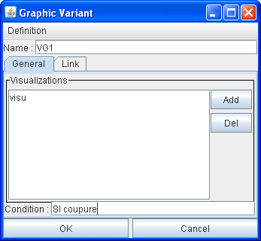

To declare the list of visualizations (tag DISPLAY_MODE) in which this graphic variant must be taken into account, we manage this list with the buttons Del and Add, which displays the following combo-box, allowing to choose among the visualizations declared in the General tab of the KB.

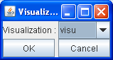

Detail of the structure STARTING_POINT (it is the same thing for TARGET_POINT)
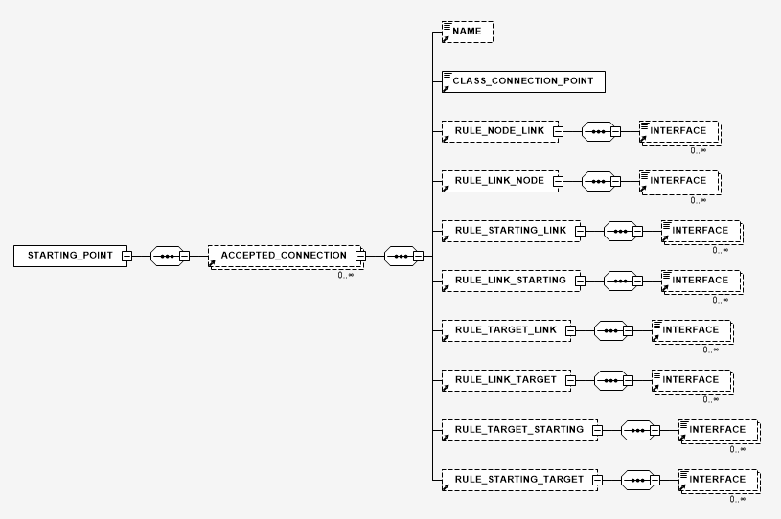

The definition of the characteristics of structures STARTING_POINT and TARGET_POINT is done by clicking on one of the buttons accessible by the tab Ports:
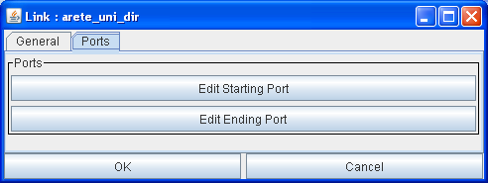

By clicking on one of these buttons, one has the list of accepted connections:
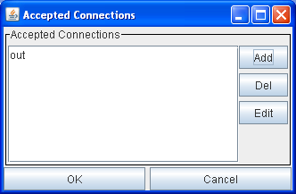

The edition of each connection is made by a window such as this one, in which the second combo-box is used to select a type of interface filling rule:

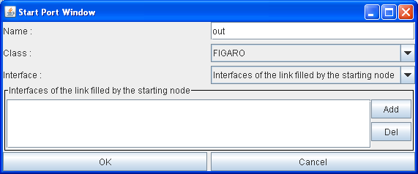
Note 1: you must select from the first combo-box a Figaro class that contains interfaces. Otherwise the button Add will display an empty list.
Note 2: the white box with the Add and Del buttons lists the interfaces filled by the rule selected in the second combo-box, which does not allow to have an overview of all the rules. To help the user find the existing rules, the relevant lines are marked with an "*" when the second combo-box is open.

Editing a particular node

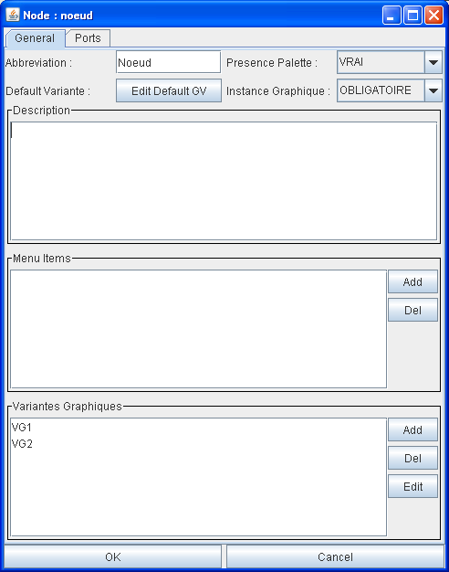

Clicking on the Add button in the "Menu items" area displays the following window that lists the choices of menu names (defined in the General tab of the KB).
Note: Only the menu names that were present in the .bdc file when launching the "XML management" command are proposed.
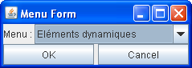

The "Ports" tab is used to manage the connection points for links:
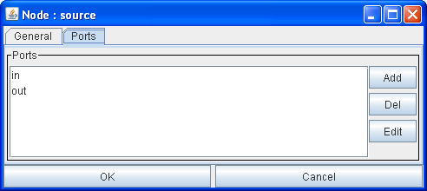

Each port can be either inherited from a parent type:
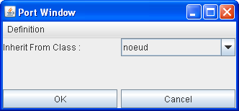

or defined directly. In this case, use the following window to give it a name and a position relative to the icon (supposedly inscribed in a rectangle whose points at the bottom left and at the top right are respectively -100, -100 coordinates and 100, 100).
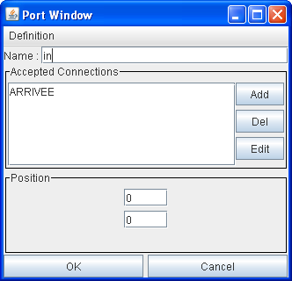

This window also makes it possible to visualize a list of the ARRIVAL or DEPARTURE ends of the links whose connection on this port is authorized.
By clicking on the Add button, the following window appears, in which a combo-box for the Name field is used to choose between DEPART and ARRIVEE of a link. The keywords are the same for editing a knowledge base in French and English (this is an anomaly that has never been corrected, to avoid incompatibilities with existing knowledge bases).
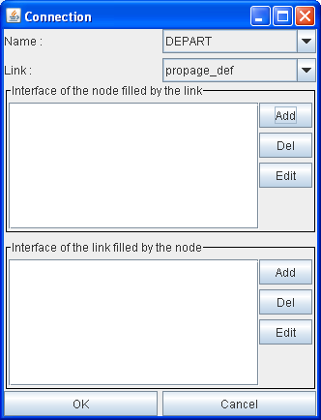

Any rules for filling interfaces are all visible in the two boxed areas of the window above.

Translating an existing knowledge base
Thanks to the translation tool, it is possible to keep the French and English versions of the same knowledge base in perfect correspondence. All that is required is to create a correspondence table between the words and expressions (automatically extracted from the text of the initial knowledge base by the translator) in both languages.
When changing the knowledge base, just add the new words and expressions to the table and run the translation to update the KB in the other language.

The convenient use of the knowledge base translator (from French to English and vice versa) assumes the following organization for the directories (below, example for the "test" knowledge base):
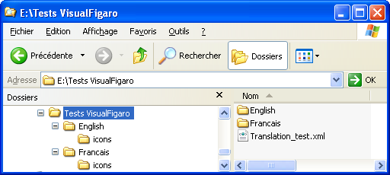

In fact, it suffices, depending on the language from which one starts, to place the knowledge base in a directory called Francais or English. The translator will, during the first translation, create the sibling directory for the other language, copy the subdirectory containing the icons and create if necessary the file containing the schema (bdceng.xsd or bdcfr.xsd).
The file containing the translation of words specific to the KB must be in the directory containing the Francais and English directories, and must be called Translation_KBname.xml. If no file of this name exists at the launch of the translator, it is created automatically, so as to be ready to accommodate the equivalences between French and English expressions specific to the knowledge base.

Once the knowledge base to be translated is loaded in VisualFigaro, the launch of the translator is done by the following menu:
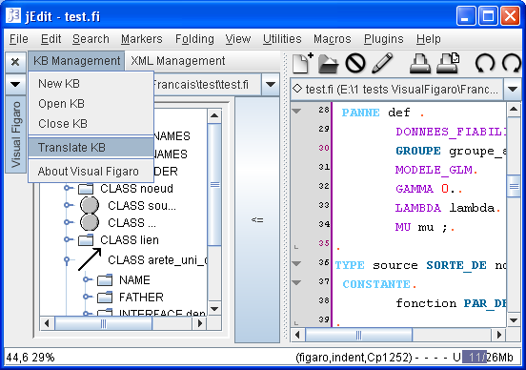

The menu remains blocked in this state (thus blocking VisualFigaro) to avoid sequences of actions with unpredictable result) as long as the translator will not have been left.
NB: if no KB is loaded, this command simply starts the translator with the same files as those used during the last translation.

The HMI of the KB Translator (it is an executable independent of VisualFigaro, which is simply launched by VisualFigaro) is then displayed, with all the fields indicating the files to be used pre-filled:

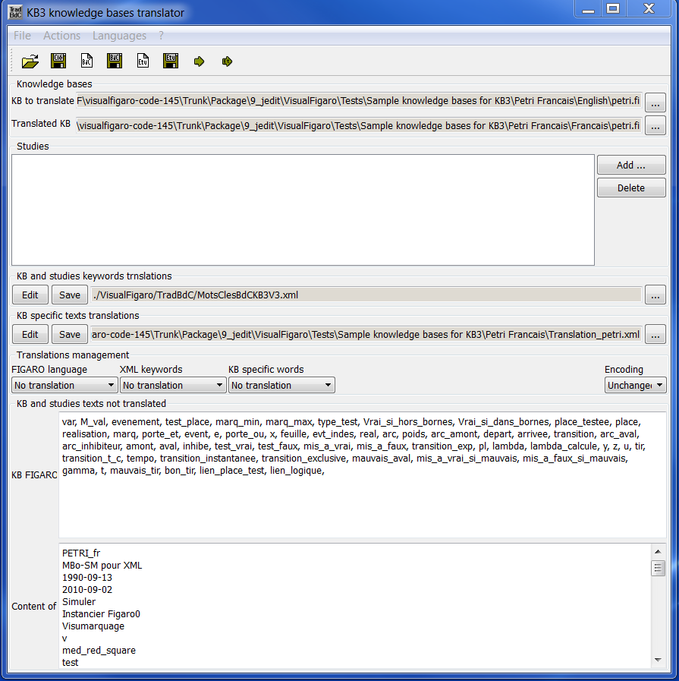

Depending on the language of the "active" KB (i.e. the KB displayed at the time of the launch of the translator), the direction of the translation is fixed towards the "other" language.
It is assumed that the names of the files of the KB in French and in English are the same, one distinguishes the languages ​​thanks to the names of directories.
However, note that if you want to be able to load the two knowledge bases simultaneously in KB3, it is necessary to give them different names (field "Name" of the main window below) inside the .bdc files.
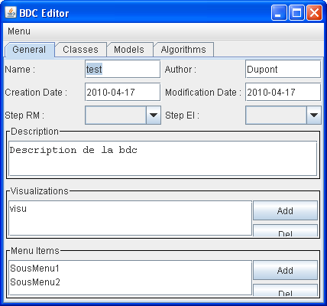

For the use of the translator itself, refer to its user manual, accessible through the menu "?" of the translator.

Precautions to be taken:
- think about "translating" bdcfr.xsd by bdceng.xsd
- if necessary change the names of icons in the "icons" directory of the target knowledge base of the translation (this is especially necessary if the names of icons are identical to the class names in the starting KB, because then the translator also translates the names of the icons)
- there must not be a line break between an opening tag and the corresponding closing tag (so in particular, do not enter a description of the knowledge base on more than one line)
- pay attention to accented characters: there may be coding problems. To check, load the .bdc files in QxmlEdit.

Editing system models

Creating a new model
VisualFigaro 2.0 introduces an important feature, the management of Figaro object files. The creation of a new model is done using the menu Object Management as shown below:

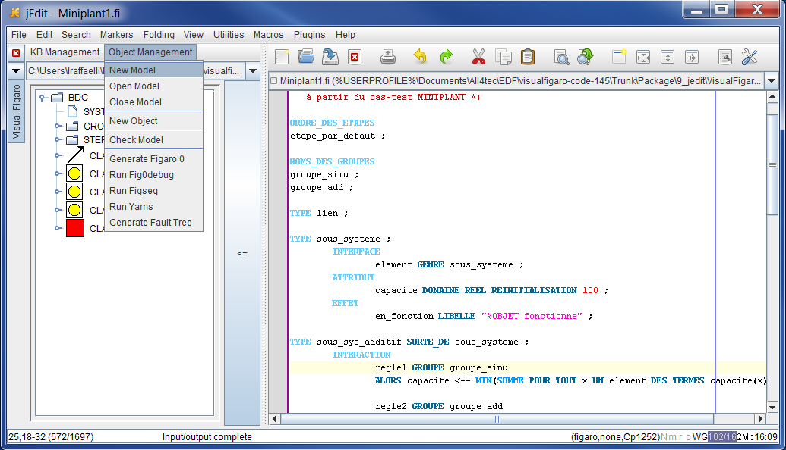

The following window is obtained:
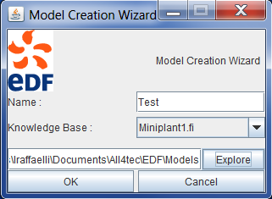
This window allows to choose a name for the model and a directory in which the model will be placed (using the "Explore" button). In addition, the combo-box Knowledge Base allows you to select the knowledge base with which the model will be associated for the duration of the session. The proposed list corresponds to all the knowledge bases opened during the current session of VisualFigaro.

By pressing the OK button, a new blank file is created in the editor.
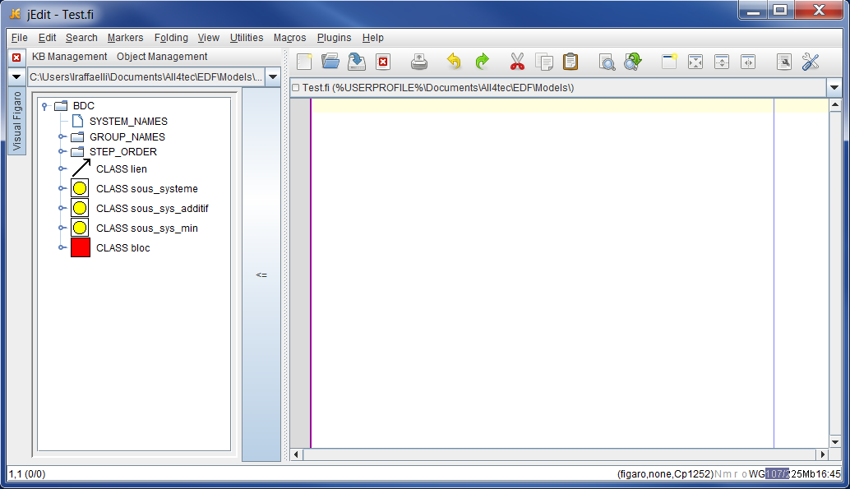

NB: The tree displayed in the left window corresponds to the knowledge to which the object file is associated.

Inserting a new object
To insert a new object into the model, select the menu Object Management and then the option New Object:
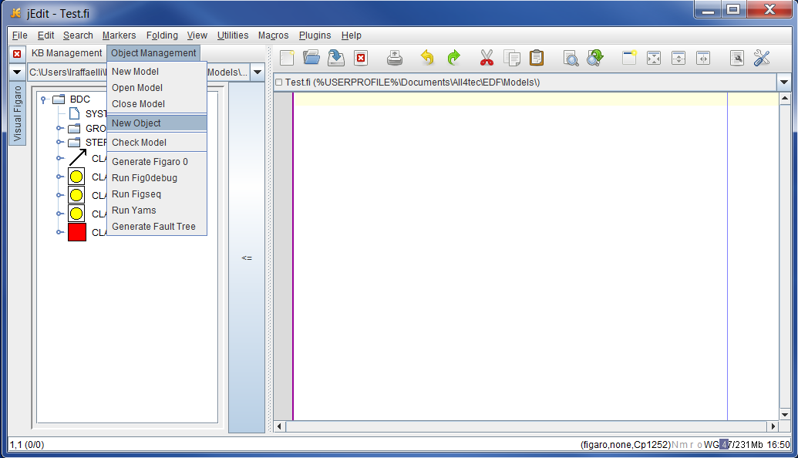

The following window opens:
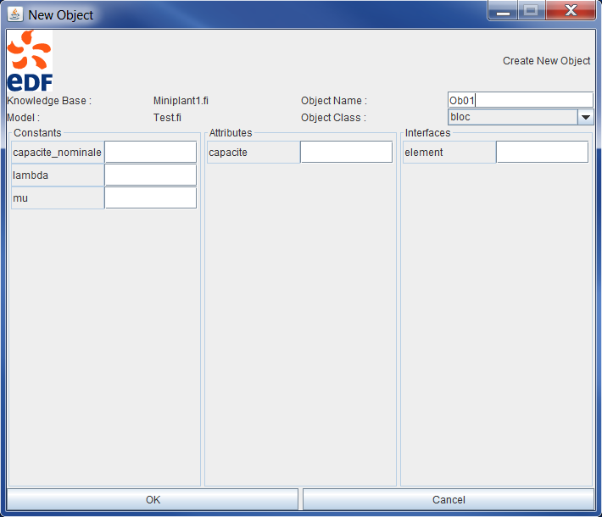

This window proposes the list of knowledge base classes and elements (constants, attributes, and interfaces) that can be associated with objects. It is necessary to at least select a class and give a name to the object to be able to create it. To give a value to the elements, just fill in the corresponding fields.
Pressing the OK button will insert the corresponding FIGARO text in the editor:

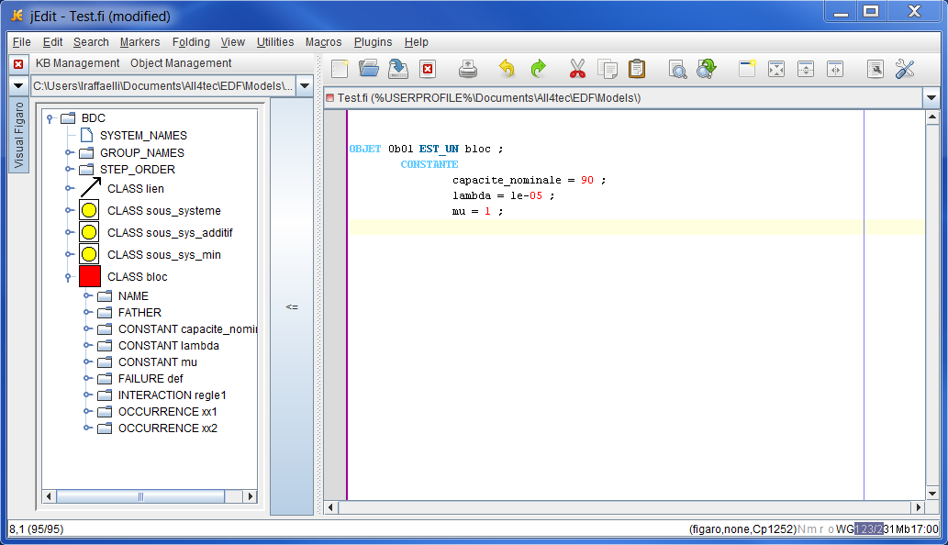

Checking the consistency of the model
The check of the model consistency is done by clicking on the menu Object Management then on the option Check Model.
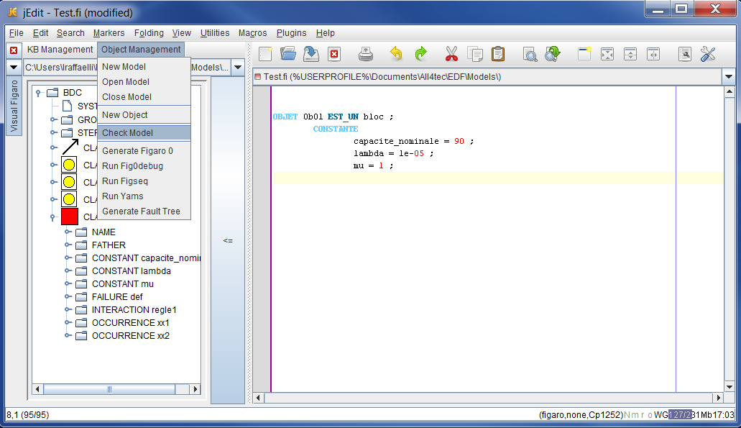

The following window is then obtained:
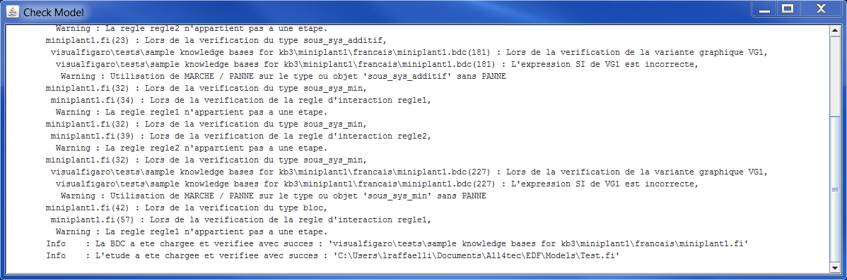

Any errors and warnings related to the model are displayed there. The consistency of the knowledge base is also verified.

Generating a Figaro 0 file
The generation of a Figaro 0 file is done by clicking on the menu Object Management then on the option Generate Figaro 0 when a model is in the active text window.
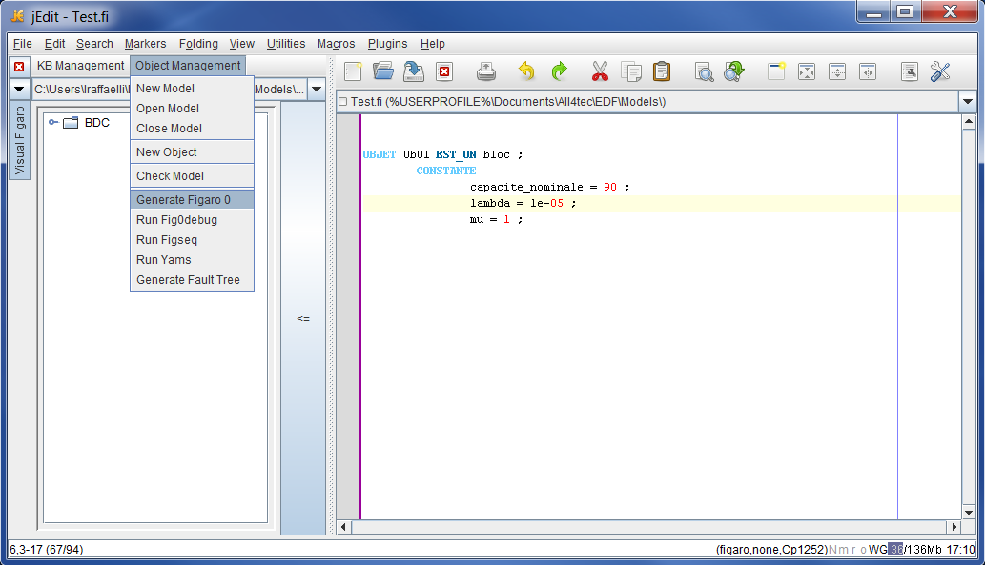

This opens the following window:
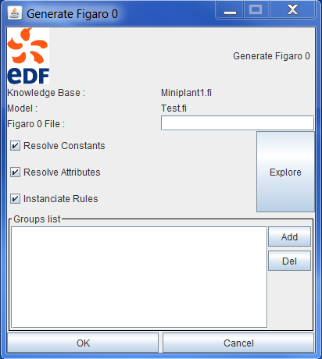

The "Resolve Constants" and "Resolve Attributes" options enable / disable the resolution (i.e. replacement of expressions by their values) of constants and attributes. The Instantiate Rules option enables the writing of rules in the generated Figaro 0 file. The Groups list window is used to add the groups of rules that will be instantiated in the final Figaro 0 file. To do this, simply click on the Add button. If no group is selected, rules of all groups will be instantiated.

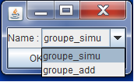

By clicking on the OK button, the Figaro 0 file is generated and displayed in JEdit.
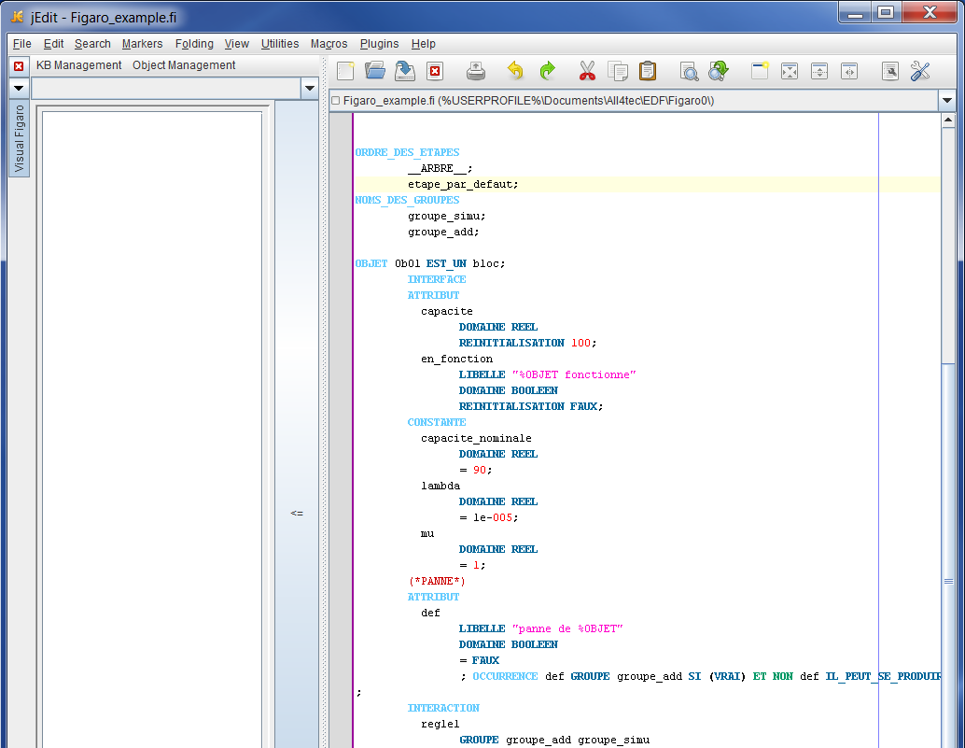

Lauching Fig0debug
To start Fig0debug, you have to click on the menu Object Management then on the option Run Fig0debug when a Figaro 0 file is open in the interface of JEdit. It is also possible to launch this command from a model, in this case the program can either invite the user to generate a new Figaro 0 file, or ask the user if he wants to use a Figaro file previously saved for this model.

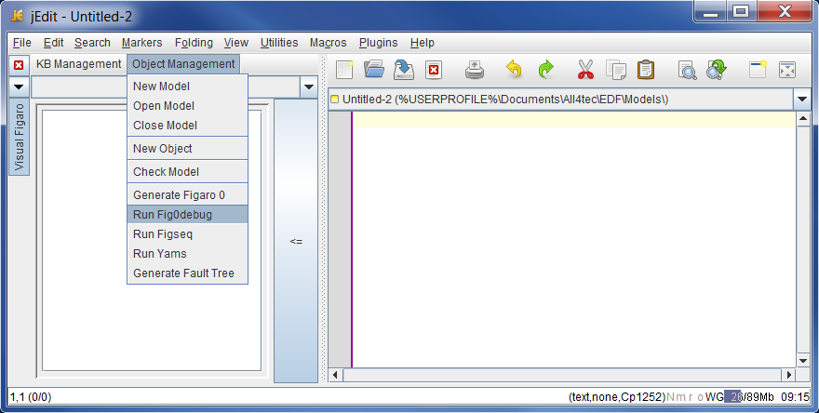

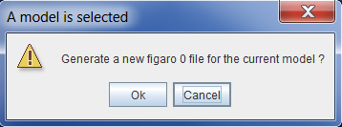

Once the Figaro 0 file is ready, Fig0debug starts.
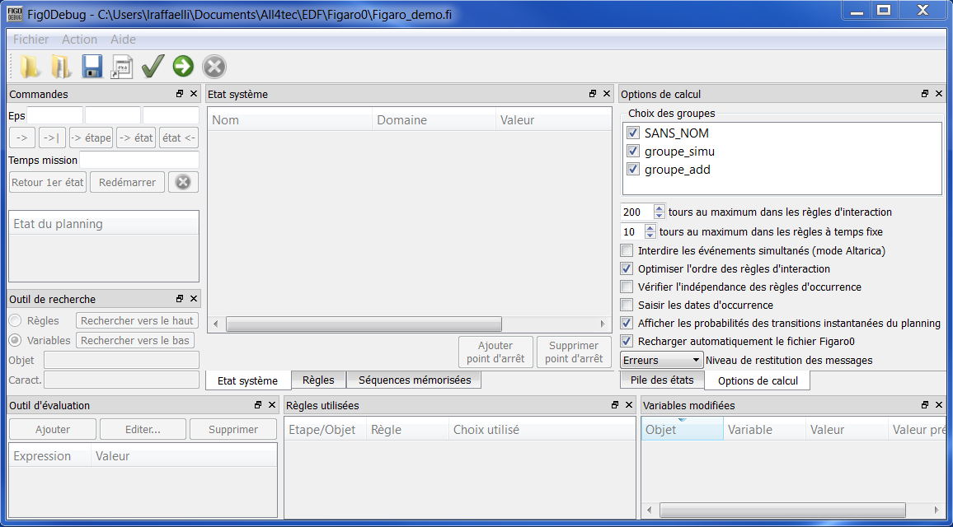

Launching Figseq
To launch Figseq, click on the option Run Figseq of the Object Management menu.
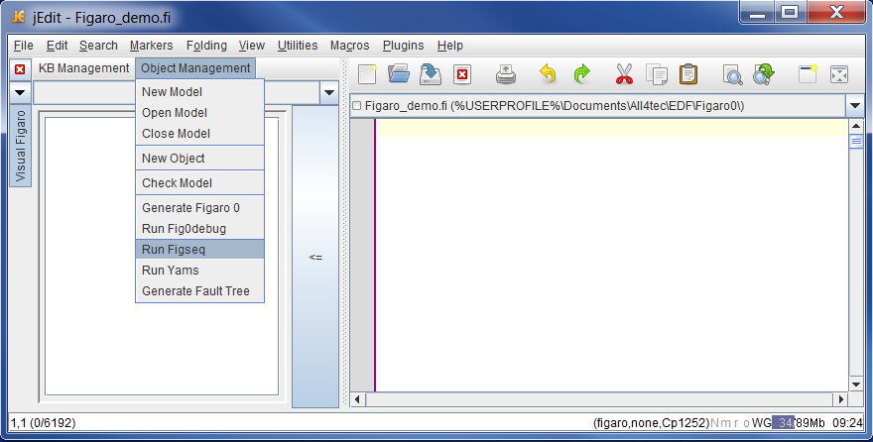

As for Fig0debug, the command works from a Figaro 0 file. If a model is selected, VisualFigaro proposes to generate a new Figaro 0 file or to reuse a Figaro 0 file previously generated for this model.
Since Figseq is a program external to the plugin and working with KB3, it is necessary to check that the path to the program in the KB3Configuration.xml files is valid. If the path is not found or the KB3Configuration.xml files are not present on the disk, an error message is displayed.

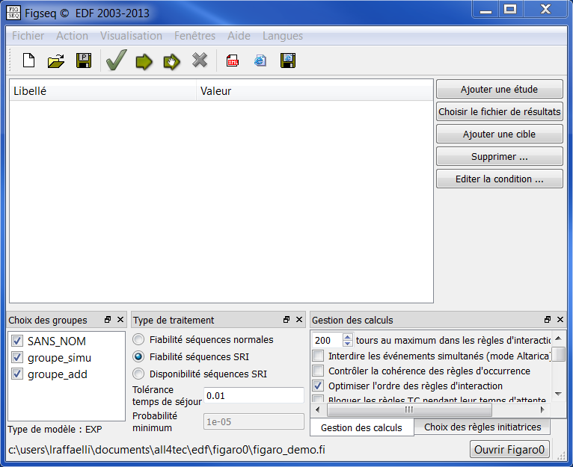

Launching Yams
To launch Yams, click on the option Run Yams in the menu Object Management.
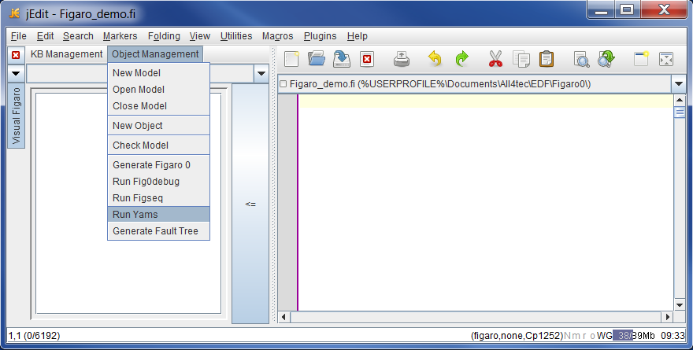

The operation of this command is the same as for the command Run Figseq. Because Yams is an add-on tool for KB3, the program path is searched for in the KB3Configuration.xml files. If the path is not found or the KB3Configuration.xml files are not present on the disk, an error message is displayed.

Yams will start with the Figaro 0 file pre-loaded:
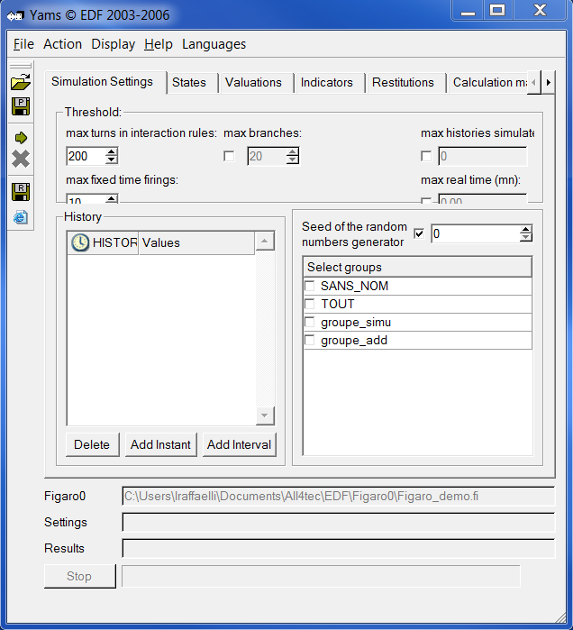

Generating a fault tree
To generate a fault tree, click on the option Generate Fault Tree of the menu Object Management when a model is selected.

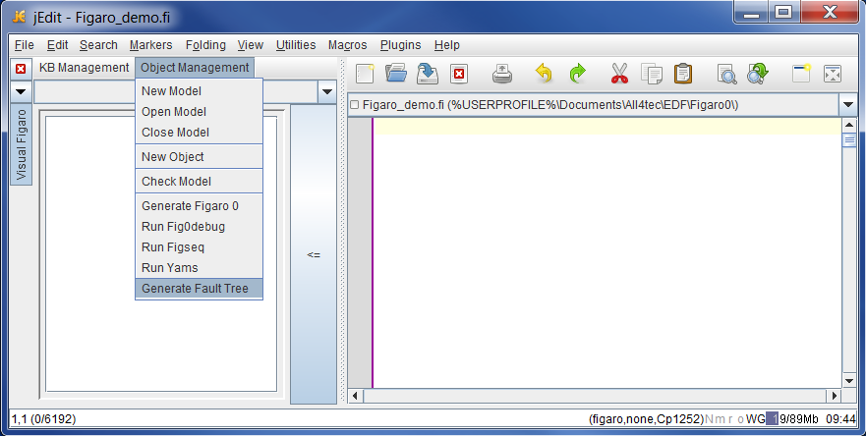

The following window opens:
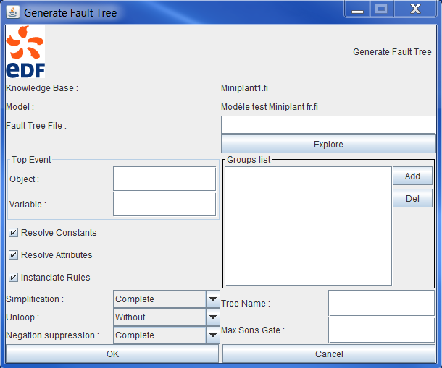

You must enter the name of the fault tree that will be generated in the Fault Tree File field. In the Top Event panel, enter the name of an object and of one of its Boolean variables that will be used as the undesired event. The Top Event corresponds to the fact that this variable takes the value TRUE. Resolve Constants and Resolve Attributes options will replace expressions by their values in the definition of constants and attributes. Instantiate Rules activates the rules that are selected in the Groups list panel (in fact without this option, the fault tree will be equal to the constant FALSE).

Once the fault tree file generated (it is an XML file), a window indicates its location:

